🥗 Healthy School Tiffin Guidelines
Include all food groups – Add whole grains, vegetables, fruits, protein, and dairy when possible.
Choose homemade food – Prefer fresh, home-cooked meals over packaged foods.
Add fruits and vegetables – Include at least one fruit and one vegetable every day.
Include protein – Use dal, beans, sprouts, paneer, curd, eggs, nuts, or seeds.
Choose healthy carbohydrates – Prefer roti, whole-grain bread, poha, upma, idli, or other whole grains.
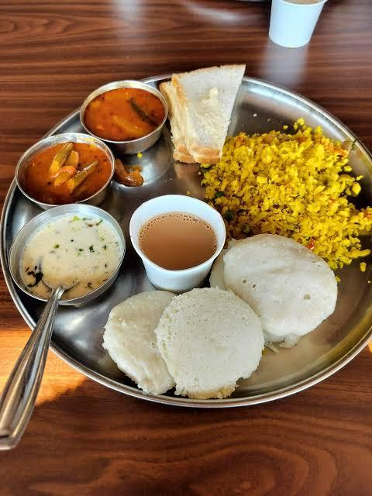

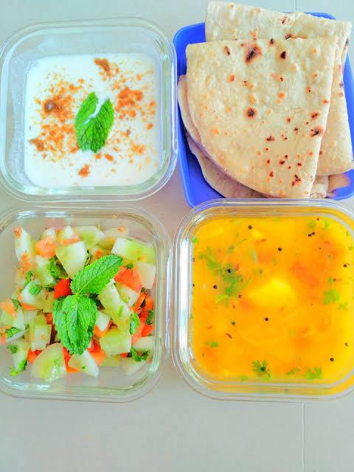
Limit junk food – Avoid chips, biscuits, sugary drinks, sweets, and highly processed snacks.
Keep sugar and salt moderate – Avoid making the tiffin excessively sweet or salty.
Pack safely – Use clean, leak-proof containers and pack food at a safe temperature.
Keep portions age-appropriate – Pack enough food to satisfy hunger without excessive portions.
Encourage water – Send a water bottle and avoid soft drinks and sugary juices.
Make it attractive – Use colourful, varied foods and child-friendly presentation.
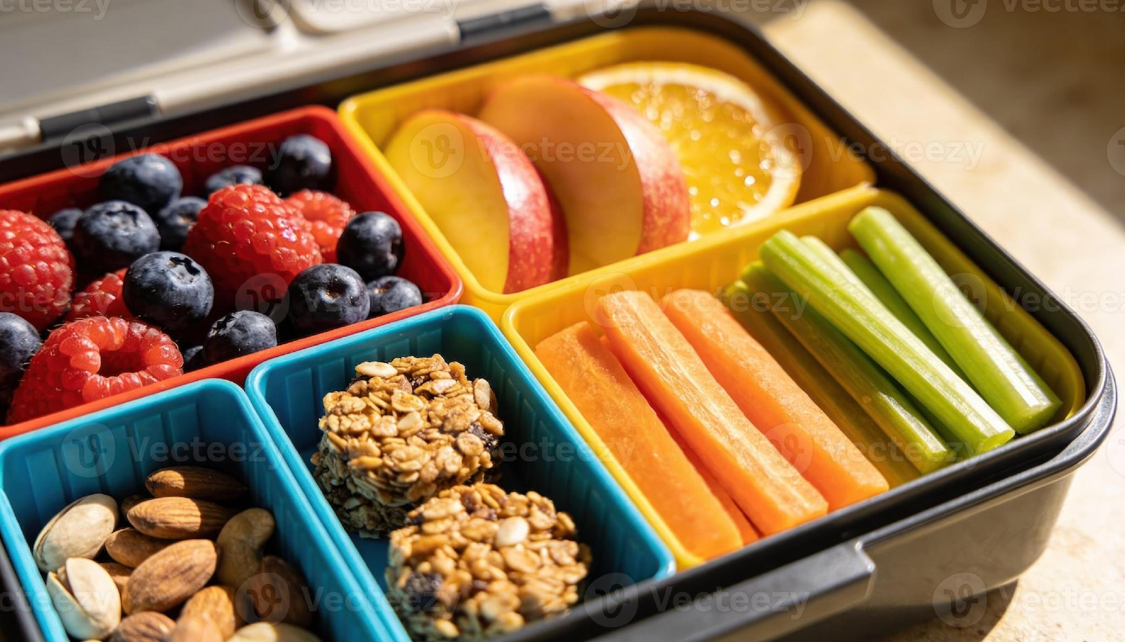

Avoid choking hazards for young children – Cut foods such as grapes and cherry tomatoes appropriately and avoid whole nuts where unsafe.

Simple rule :
A healthy tiffin should be colourful, balanced, fresh, tasty, and mostly homemade.

